**Microsoft App-V (Application Virtualization)**

**What is App-V?**

* **Microsoft App-V (Application Virtualization) is a technology that allows applications to run on computers without installing them directly on the operating system.**
* **Applications are delivered in a virtualized package and run inside an isolated environment called a virtual bubble.**
* **This avoids software conflicts and makes deployment easier.**

**Key Features of App-V**

1. **Virtualization – Applications run in isolated environments.**
2. **Centralized Deployment – Apps are stored on a server and streamed to client PCs.**
3. **Multiple Versions – Different versions of the same app can run together without conflict.**
4. **Easy Updates – Admins can update or patch apps centrally without reinstalling.**
5. **Improved Security – Apps run in a sandbox, reducing risk to the host system.**

**Benefits of App-V**

* **No Installation Hassle – Users run apps instantly without full installation.**
* **Cost Saving – Easier management reduces IT effort.**
* **Compatibility – Legacy apps run on modern Windows versions.**
* **Disaster Recovery – Apps can be streamed to any machine quickly.**

**Example**

* **In a company, instead of installing MS Office on 500 PCs, the IT team sequences it with App-V Sequencer and streams it from a central server.**
* **Users open Word, Excel, or PowerPoint directly as if installed locally, but no actual installation happened on their PCs.**

**In short:  
 App-V = Applications delivered as a service (streamed/virtualized), not installed traditionally.**

**What is App-V Sequencer?**

* The **App-V Sequencer** (part of Microsoft Application Virtualization, or App-V) is a **wizard-based tool** that captures and records an application's installation and setup processes to package it into a virtualized format. This results in package files such as .SFT, .OSD, .ICO, and .SPRJ, which can be deployed and run on client machines without traditional installation.
* It is a core component of **Microsoft App-V**, which enables applications to run in isolated **“bubbles”**, avoiding conflicts with other apps or the operating system and simplifying centralized deployment.

**Why Use App-V Sequencer?**

* **Conflict Reduction**: Multiple versions of an application can coexist without interfering.
* **Simplified Deployment and Rollback**: Virtual applications can be deployed centrally and easily rolled back or updated.
* **Improved Compatibility**: Legacy apps can be virtualized without altering the host OS.

**Installing Microsoft App-V Sequencer**

**Step 1: Download Windows ADK**

* Go to the Microsoft website: Windows ADK Download
* Download the **Windows Assessment and Deployment Kit (ADK)** installer for your Windows version.

**Step 2: Run the ADK Installer**

* Double-click the downloaded **ADK setup file**.
* Select **Install the Windows Assessment and Deployment Kit to this computer**.

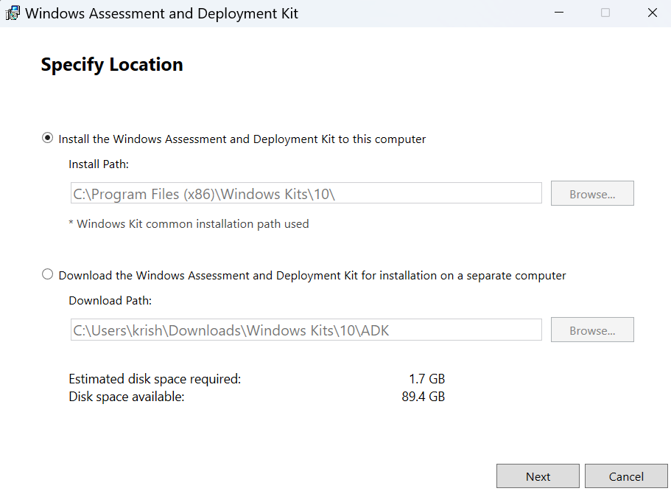

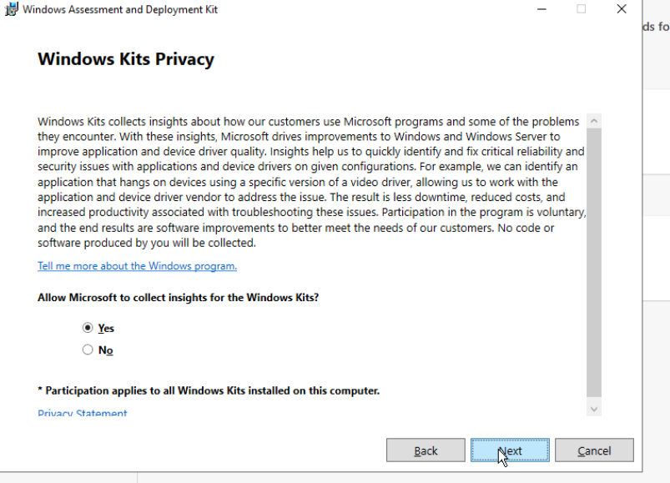

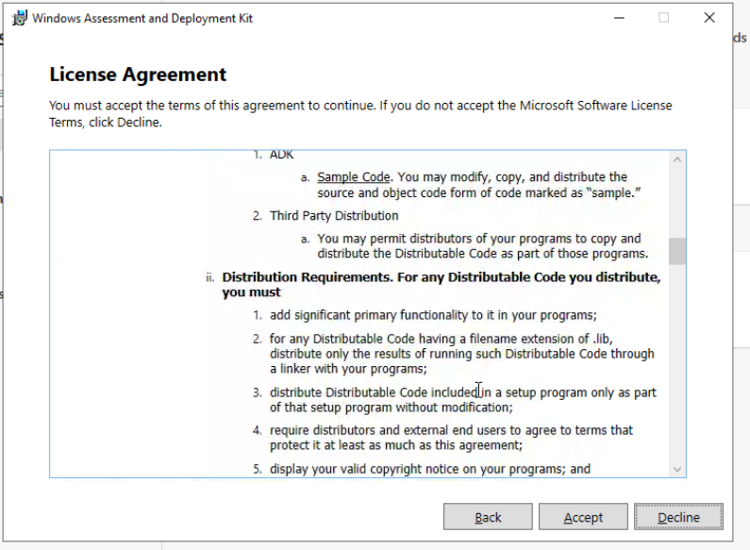

**Step 3: Select Components**

* When prompted to choose features, **check the option** for:
  + **Microsoft Application Virtualization (App-V) Sequencer**
* You may also install additional tools if required.

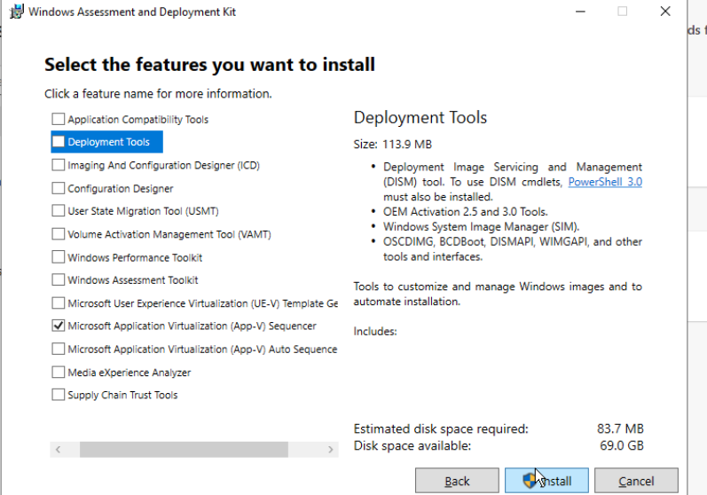

**Step 4: Install on a Clean Machine**

* Make sure you install on a **clean machine** (fresh Windows setup, no extra apps).
* Ensure **App-V Client is NOT enabled** on this machine.

**Step 5: Complete Installation**

* Click **Install** and wait for the setup to finish.
* Once done, click **Close**.

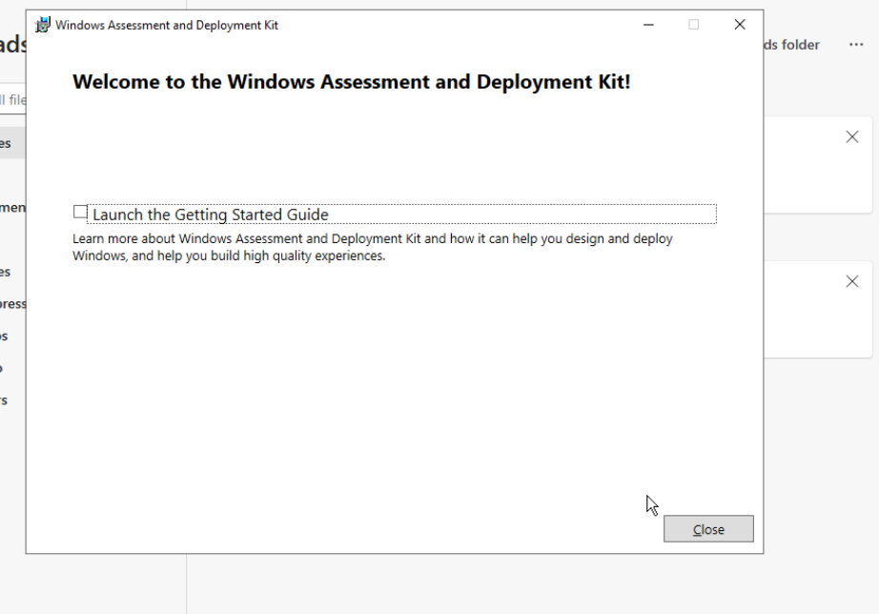

**Step 6: Launch App-V Sequencer**

* Open the **Start Menu**.
* Search and launch **Microsoft Application Virtualization (App-V) Sequencer**.

